

**Newspaper Seller Case Study**

## **Problem Definition:**

The newspaper seller wants to determine how many newspapers he should buy each day in order to **maximize his profits**. His present method of determining the quantity of Newspaper is based upon his best guess or estimate of the daily demand for the day news.

## **Assumptions and Parameters:**

* **Selling Price (P):** $0.50 per newspaper
* **Cost Price (C):** $0.33 per newspaper
* **Scrap Value (S):** $0.05 per unsold newspaper
* **X:** Quantity of newspapers purchased
* **d:** Daily demand
* **Z:** Daily profit

## **Day Type Probability Distribution:**

|  |  |  |  |
| --- | --- | --- | --- |
| Type of Newsday | Probability | Cumulative | Random Number Range |
| Good | 0.35 | 0.35 | 0 ≤ R < 0.35 |
| Fair | 0.45 | 0.80 | 0.35 ≤ R < 0.80 |
| Poor | 0.20 | 1.00 | 0.80 ≤ R ≤ 1 |

## **Demand Distribution:**

(For demand values: 40, 50, 60, 70, 80, 90, 100 newspapers)

You will need to calculate the Cumulative Distribution Function (CDF) for demand for each type of day (Good, Fair, Poor) using your Excel data. You can present each distribution in a table format like:

|  |  |  |  |
| --- | --- | --- | --- |
|  | Demand Prob. Dist. | | |
| Demand | Good | Fair | Poor |
| 40 | 0.03 | 0.10 | 0.44 |
| 50 | 0.05 | 0.18 | 0.22 |
| 60 | 0.15 | 0.40 | 0.16 |
| 70 | 0.20 | 0.20 | 0.12 |
| 80 | 0.35 | 0.08 | 0.06 |
| 90 | 0.15 | 0.04 | 0.00 |
| 100 | 0.07 | 0.00 | 0.00 |

## **Model Formulation:**

***Key Equations:***

1. Revenue Sales = min(d, X) × P
2. Excess Demand = max(X, d) − d
3. Profit per newspaper sold = P − C
4. Lost Profit = (X < d) ? (d − X) × (P − C)
5. Number of Scrap = max(X − d, 0)
6. Scrap Salvage = Number of Scrap × S
7. Cost of Newspapers = X × C
8. Daily Profit (Z) = Revenue Sales − Cost of Newspapers − Lost Profit + Scrap Salvage

## **Objective**

Use simulation (e.g., random number generation for day type and demand) to estimate the optimal number of newspapers to purchase daily (X) that maximizes the average profit Z (X, d).

## **Implementation**

#### **Excel Sheet:**

#### **C++ Code:**

#include<bits/stdc++.h>  
using namespace std;  
  
constexpr int days = 30;  
constexpr int quantity = 70;  
constexpr int paper_cost = 33;  
constexpr int iterations = 10;  
constexpr float scrap_sale = 5;  
constexpr float paper_sell = 50;  
  
*/// Types of News day*constexpr float GOOD = 0.35;  
constexpr float FAIR = 0.45;  
constexpr float POOR = 0.20;  
  
float cumulative_prop[3] = {  
 GOOD,  
 GOOD + FAIR,  
 GOOD + FAIR + POOR,  
};  
  
struct RD {  
 float lower, upper;  
} RandDist[3]{  
 {0.0, GOOD - 0.01},  
 {GOOD, GOOD + FAIR - 0.01},  
 {GOOD + FAIR, GOOD + FAIR + POOR}  
};  
  
struct DayData {  
 int day;  
 double R1;  
 string type;  
 double R2;  
 int demand;  
 int revenue_sales;  
 int excess_demand;  
 int lost_profit_excess;  
 int num_scrap;  
 int salvage_scrap;  
 int daily_profit;  
};  
  
int getDemand(const string& dayType, const double R) {  
 if (dayType == "Good") {  
 if (R < 0.03) return 40;  
 if (R < 0.08) return 50;  
 if (R < 0.23) return 60;  
 if (R < 0.43) return 70;  
 if (R < 0.78) return 80;  
 if (R < 0.93) return 90;  
 return 100;  
 }  
  
 if (dayType == "Fair") {  
 if (R < 0.10) return 40;  
 if (R < 0.28) return 50;  
 if (R < 0.68) return 60;  
 if (R < 0.88) return 70;  
 if (R < 0.96) return 80;  
 return 90;  
 }  
  
 if (dayType == "Poor") {  
 if (R < 0.44) return 40;  
 if (R < 0.66) return 50;  
 if (R < 0.82) return 60;  
 if (R < 0.94) return 70;  
 return 80;  
 }  
 return {};  
}  
  
vector<DayData> simulate(int X, int N) {  
 vector<DayData> results;  
 random_device rd;  
 mt19937 gen(rd());  
 uniform_real_distribution<> dis(0.0, 1.0);  
  
 for (int day = 1; day <= N; ++day) {  
 double R1 = dis(gen);  
 string type;  
 if (R1 < cumulative_prop[0]) type = "Good";  
 else if (R1 < cumulative_prop[1]) type = "Fair";  
 else type = "Poor";  
  
 double R2 = dis(gen);  
 int demand = getDemand(type, R2);  
  
 int revenue_sales = min(X, demand) * paper_sell;  
 int excess_demand = max(demand - X, 0);  
 int lost_profit_excess = excess_demand * (paper_sell - paper_cost);  
 int num_scrap = max(X - demand, 0);  
 int salvage_scrap = num_scrap * scrap_sale;  
 int daily_profit = revenue_sales + salvage_scrap - X * paper_cost;  
  
 DayData data = {day, R1, type, R2, demand, revenue_sales,

excess_demand, lost_profit_excess, num_scrap, salvage_scrap, daily_profit};  
 results.push_back(data);  
 }  
 return results;  
}  
  
void writeTableToFile(const vector< DayData > &results, const string filename) {  
 ofstream outfile(filename);  
 if (!outfile) return void (cerr << "NOOOOOOOOOOOOOOOO such File: " << filename << endl);  
  
 outfile << "Day\t|\tR1\t|\tType\t|\tR2\t|\tDemand\t|\tRevenue\t|\tExcessD\t|\tLostProfit\t|\tScrap\t|\tSalvage\t|\tProfit\n";  
 for (const auto &data: results) {  
 outfile << data.day << "\t| \t"  
 << fixed << setprecision(2) << data.R1 << "\t| \t"  
 << data.type << "\t| \t"  
 << fixed << setprecision(2) << data.R2 << "\t| \t"  
 << data.demand << "\t| \t"  
 << data.revenue_sales << "\t| \t"  
 << data.excess_demand << "\t| \t"  
 << data.lost_profit_excess << "\t| \t"  
 << data.num_scrap << "\t| \t"  
 << data.salvage_scrap << "\t| \t"  
 << data.daily_profit << "\n";  
 }  
 outfile.close();  
}  
  
int main() {  
 int N_large = 1000;  
 vector< int > X_values = {40, 50, 60, 70, 80, 90, 100};  
 double best_avg_profit = -numeric_limits< double >::*max*();  
 int best_X = -1;  
  
 cout << "Let's Simulate...\n";  
 for (int X: X_values) {  
 auto results = simulate(X, N_large);  
 double total_profit = 0;  
  
 for (const auto &data: results) total_profit += data.daily_profit;  
  
 double avg_profit = total_profit / N_large;  
 cout << "Quantity X = " << X << ", Average Profit = " << fixed << setprecision(2)

<< avg_profit << " cents\n";  
 if (avg_profit > best_avg_profit) best_avg_profit = avg_profit, best_X = X;  
 }  
  
 cout << "\nOptimal quantity to buy: " << best_X << " newspapers\n";  
 cout << "Expected avg profit: " << fixed << setprecision(2) << best_avg_profit << " cents per day\n";  
  
 auto table_results = simulate(best_X, days);  
 writeTableToFile(table_results, "newspaper_simulation.txt");  
  
 double table_total_profit = 0;  
 for (const auto &data: table_results) {  
 table_total_profit += data.daily_profit;  
 }  
 double table_avg_profit = table_total_profit / days;  
 cout << "\nAverage profit over " << days << " days with X = " << best_X << ": "

<< fixed << setprecision(2) <<  
 table_avg_profit << " cents\n";  
  
 return 0;  
}

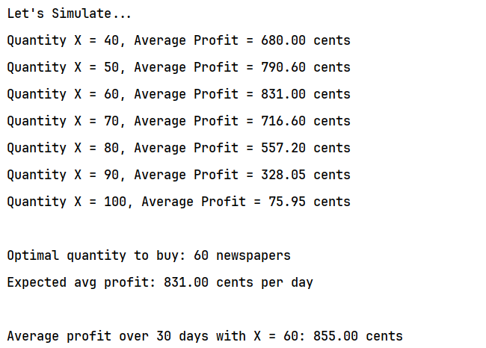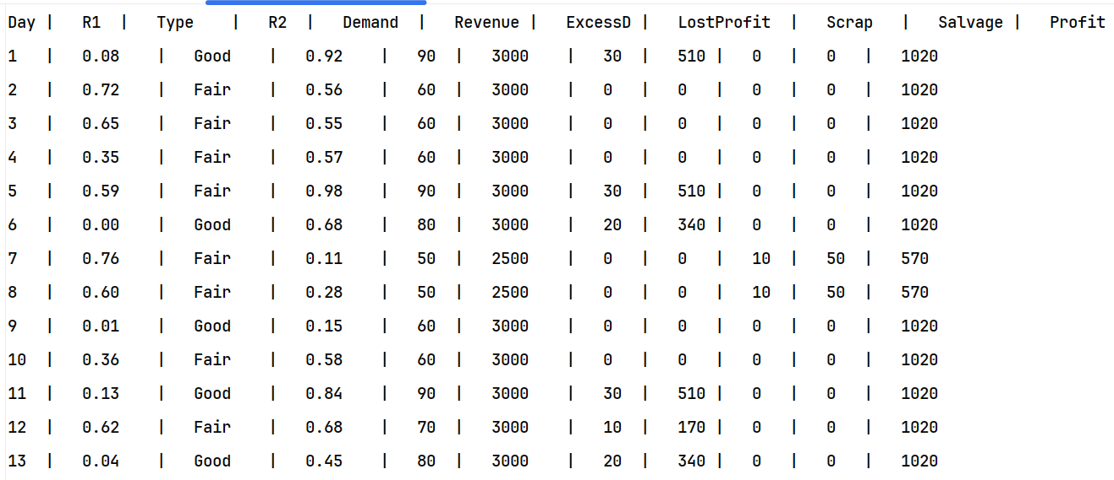

**Run**

## **GUI Presentation**

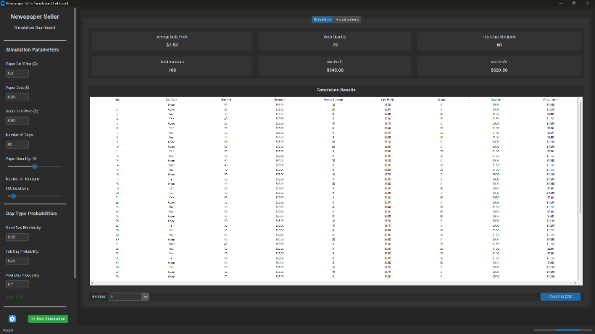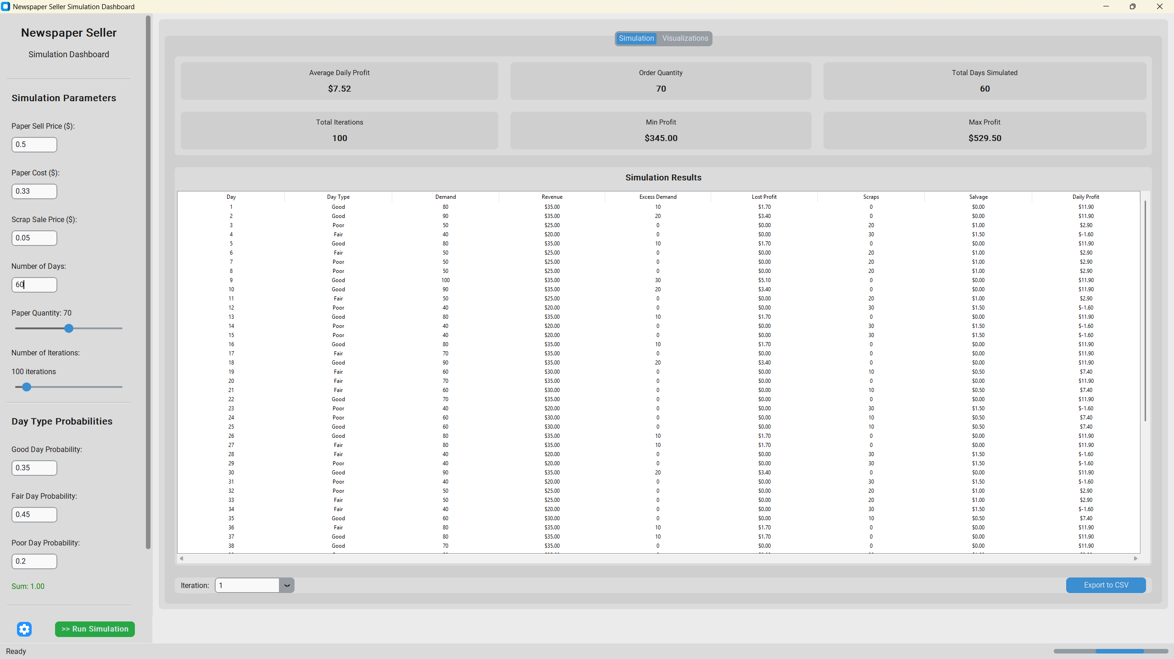

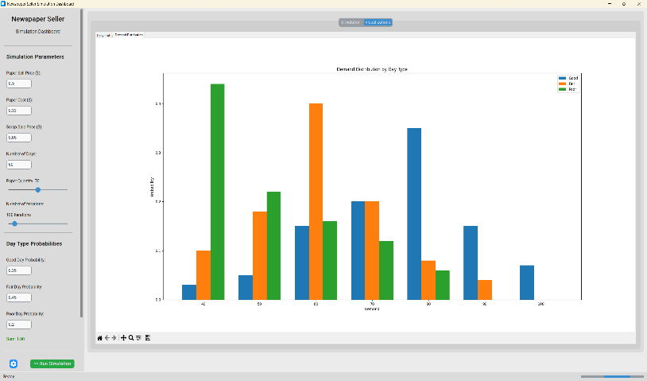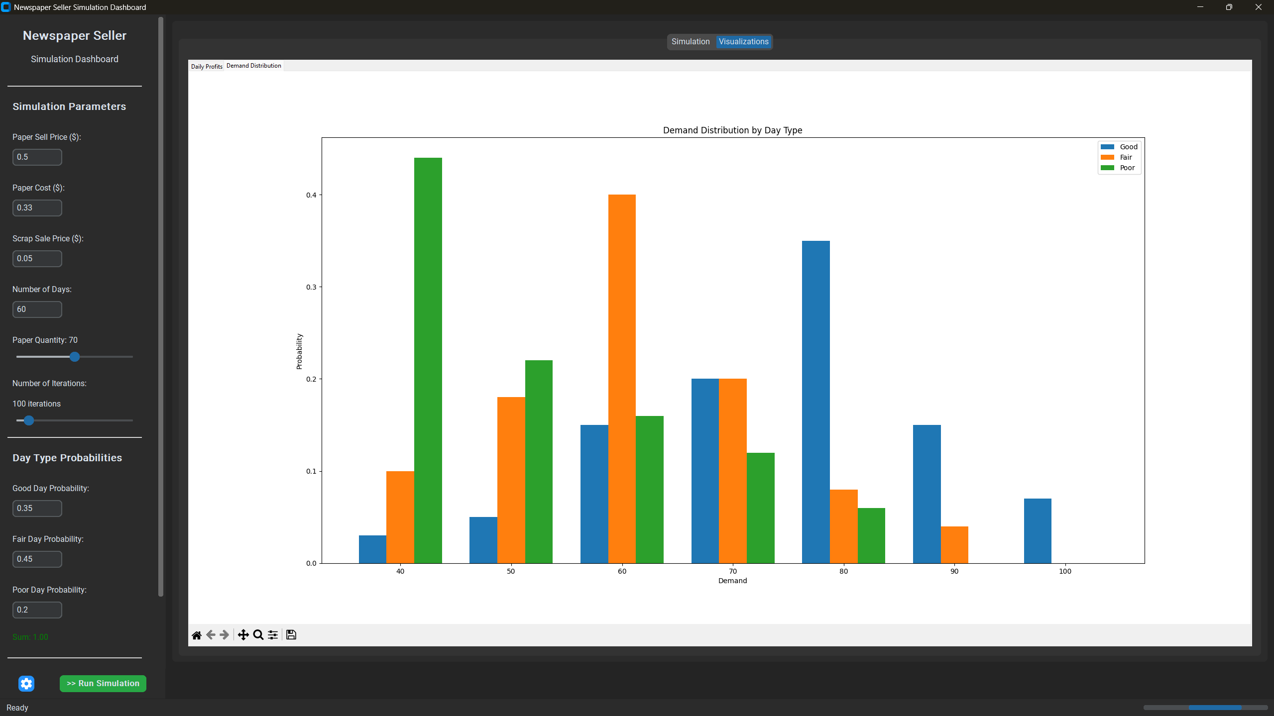

## **Flowchart**

## **Results and Conclusion**

* Present results in a table/graph: Quantity vs. Average Profit.
* Interpret how demand patterns and day types of influence profitability.